Consent Form

Functional Transcranial Doppler Imaging of Brain Activity in Response to Pictorial Stimuli

IRB # 2009E7457

We are asking you to take part in a research study because you are a healthy individual aged 18 or older. In this study, researchers will monitor your brain activity while you passively view pictures on a computer screen. You will also be asked to complete a number of questionnaires, which will ask about basic demographic information, as well as your mood, personality characteristics and patterns of consumption and feelings about food, alcohol and tobacco. The study consists of one session lasting approximately one hour. The study will be conducted by Dr. Natalie Ceballos (nc18@txstate.edu; 512-245-8709) and Dr. Reiko Graham (rg30@txstate.edu; 512-2445-6805) in the Psychology Department of Texas State University.

In order to decide whether or not you wish to be part of this study, you need to know enough about its risks and benefits in order to make an informed judgment. This consent form gives you detailed information about the study, which a member of the research team will also discuss with you. By reading this form and talking to the researchers, you will learn about the different aspects of this research: its purpose, the procedures that will be performed, any risks of the procedures, and benefits of being in the study. Once you fully understand the study, you will be asked if you wish to participate. If so, you will be asked to sign this consent form.

Description of the Procedure: In this study you will be asked to do two things.

- First, you will be asked to complete pencil-and-paper questionnaires, which will ask about basic background information (age, gender, ethnicity, etc.), your mood, personality characteristics and whether or not you smoke cigarettes or consume alcohol on a regular basis. Also, you will be asked to provide (in writing) information regarding your feelings about food, alcohol and tobacco. This portion of the experiment will require approximately 30 minutes.
- Next, you will be fitted with a headband that holds two non-invasive ultrasound probes in place on either side of your head. A non-toxic, salty gel will be placed between the probes and your skin. This method uses the same Doppler technology as a standard ultrasound machine, which one might encounter in a doctor’s office. Through these harmless probes, researchers will continuously monitor flow within specific blood vessels in your brain while you passively view a variety of pictures on the computer screen. Picture categories may include images of food, people, household items, alcohol, tobacco, shapes, etc. Example pictures are given at the end of this consent form. This portion of the experiment will require approximately 30 minutes.

Risks: There are no known risks associated with viewing objects or pictures other than what is required for prolonged concentration, which could result in fatigue. Although Doppler ultrasound technology is completely non-invasive, some participants may experience slight discomfort from wearing the fitted headband that contains the probes. If you become uncomfortable at any time during your time in the lab, let the researchers know and the study will be stopped.

Also, if you find the pictures used in this study to be overly upsetting or distressing, please inform the researcher so that they can terminate the experiment. These pictures are of common items that you might see on a daily basis, so we do not expect that they will be too distressing. However, if for any reason you feel distressed or upset, the experiment will end. At the end of the consent document, we have included examples of the types of pictures you might see in this study.

You will be asked to provide information about your consumption patterns and feelings about food, alcohol and tobacco. It is also important to note that you may choose not to answer any question for any reason. All of this information will be held in the strictest confidence. Your information will be coded with a participant number and stored separately from your name or other identifying information in locked offices. Only the researchers and their assistants will have access to this information. In the even that results of the study are published or presented at a conference, the information obtained from the study will be presented in aggregate such that specific individuals’ data will not be identifiable.

If you find any part of this study to be too upsetting or distressing, and if immediate care is needed, it is available at the Health Center at Texas State University (behind LBJ Student Center and Jackson Hall). Phone: day: 512-245-2161, after hours: 512-245-2167.

Psychological assistance may be obtained at the University Counseling Center. Location: 5-4.1 LBJ Student Center; Phone: 512-245-2208; E-mail: counselingcenter@txstate.edu.

Further information concerning your rights as a research participant can be obtained from the Texas State University Institutional Review Board at (512) 245-2314 or IRB@txstate.edu.

Benefits: One of the benefits of participating in this study is the sense of satisfaction that comes with contributing to scientific knowledge that will further our understanding how college students feel about pictures of common everyday items.

Compensation: You may be given bonus credit for Psychology courses, at the discretion of your instructor. If you choose not to participate, you may still be entitled to gain extra credit for these courses by participating in other experiments, attending talks or events on campus, or completing short written assignments (e.g., movie reviews, thought papers). Check with you instructor for clarification of your options.

Right to Withdraw: At any time, you may choose not to be in the study. If you withdraw from the study, no new data about you will be collected. You may also withdraw your authorization for us to use your data that have already been collected (other than the data needed to keep track of your withdrawal), but you must do this in writing.

Your decision not to participate, or to withdraw from the study, will not involve any penalty or loss of benefits to which you are entitled. If you decide to withdraw, we ask that you contact Dr. Natalie Ceballos or Dr. Reiko Graham in the Psychology Department at Texas State University, San Marcos, TX 78666. At that time, you will be asked for your permission to continue using the information about you that has already been collected prior to your withdrawal.

Early withdrawal will not penalize your relationship with the Department of Psychology or Texas State University.

Confidentiality: Study records that identify you will be kept confidential as required by law. Federal Privacy Regulations provide safeguards for privacy, security and authorized access to any information that you give. Except when required by law, you will not be identified by name, social security number, address, telephone number, or any other direct personal identifier on any study records disclosed outside of Texas State University. For records disclosed outside of Texas State University, you will be assigned a unique code number that will not identify you in any way. The key to this code will be kept in a locked file in the offices of Dr. Ceballos and Dr. Graham. Paper records of data will be retained for a period of 3 years, after which these items will be destroyed.

Questions concerning the study may be directed to Dr. Natalie Ceballos or Dr. Reiko Graham in the Department of Psychology, Texas State University, San Marcos, TX 78666; (512) 245-2526.

For questions regarding your rights as a research participant, contact the Texas State University Institutional Review Board at (512) 245-2314, Dr. Jon Lasser (512-245-3413; lasser@txstate.edu), and/or Ms. Becky Northcut , Compliance Specialist, 512-245-2102.

Statement of Consent: “The purpose of this study, the procedures to be followed, risks and benefits have been explained to me. I have been allowed to ask any questions on my mind, and my questions have been answered to my satisfaction. I have been told to contact Dr. Natalie Ceballos and/or Dr. Reiko Graham in the Department of Psychology at Texas State University if I have additional questions or concerns. I have read this consent form and agree to be in this study, with the understanding that I may withdraw at any time. I have been told that I will be given a signed copy of this consent form.”

________________________________________________________________________
Participant’s Name (PRINT)

________________________________ __________________
Participant’s Signature Date

___________________________________________
Signature of Person Obtaining Consent
Picture Examples:

In this study you might see pictures that fall within the following categories:

Pictures of Food: Pictures of People: Pictures of Beverages:
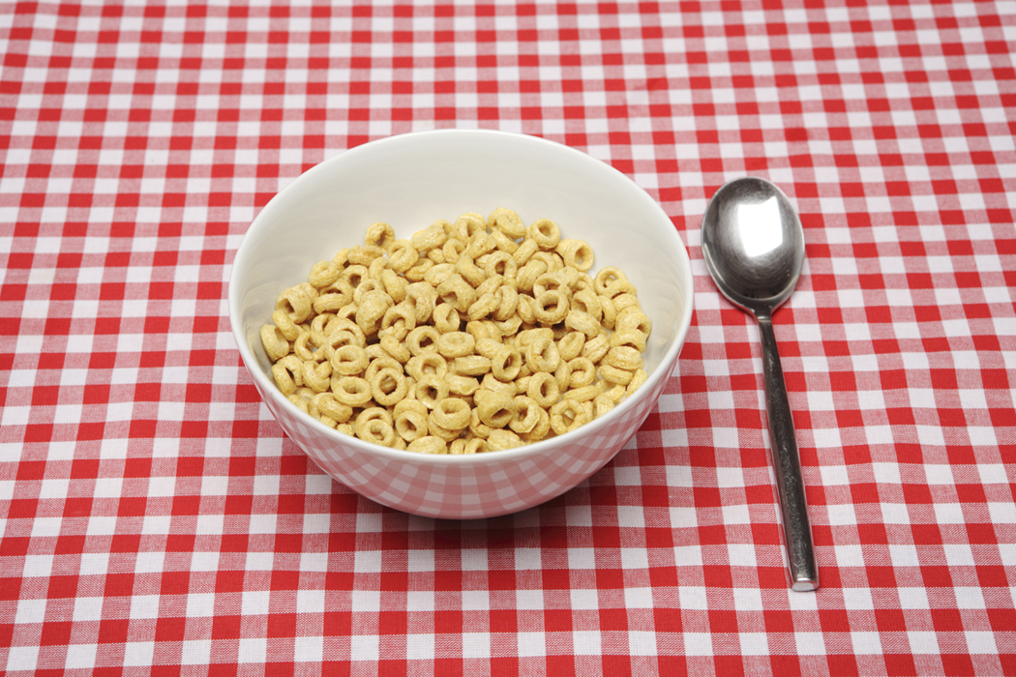


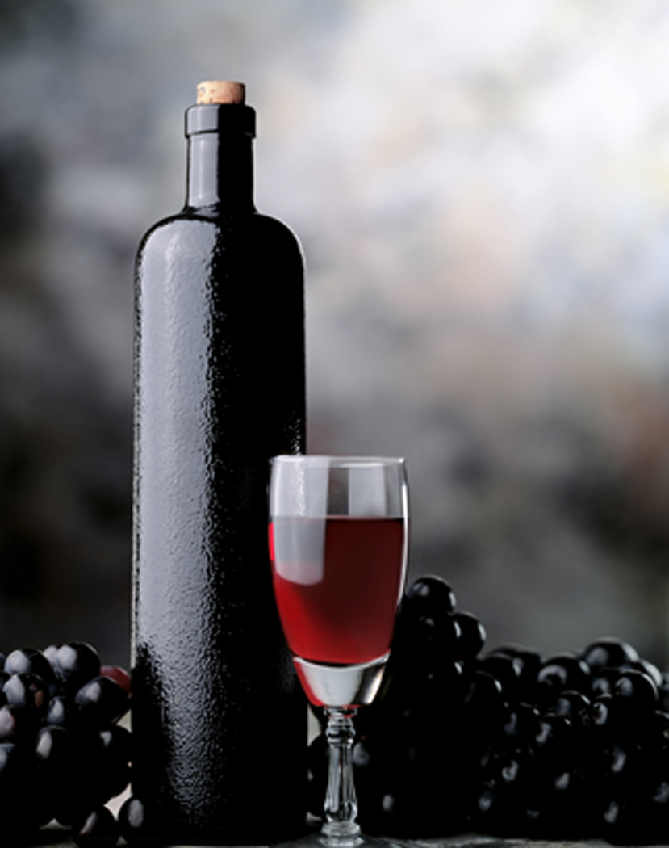


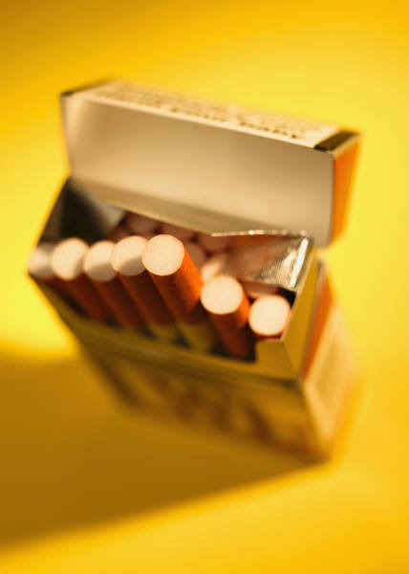

Pictures of Objects: Pictures of Shapes: Pictures of Activities:

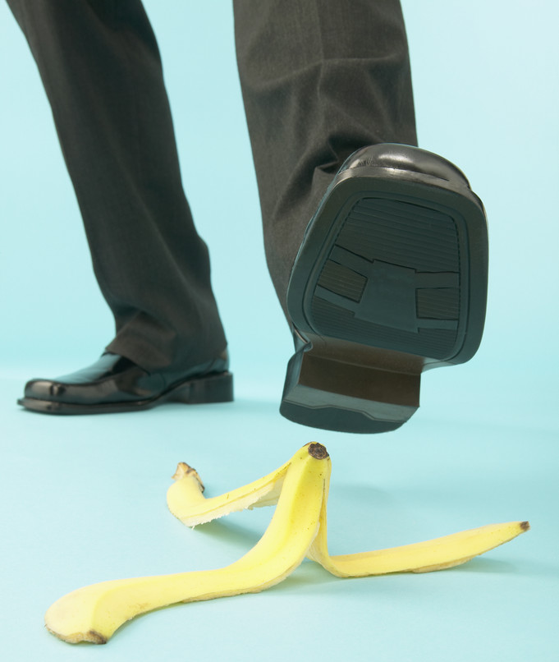

Pictures of Complex Scenes:


